


High Tech, Science, & Design
Breakthroughs in health, sustainability, and quality of life often come from the world of High Tech, Science, & Design. In this world you work on smart ideas that can change life forever.
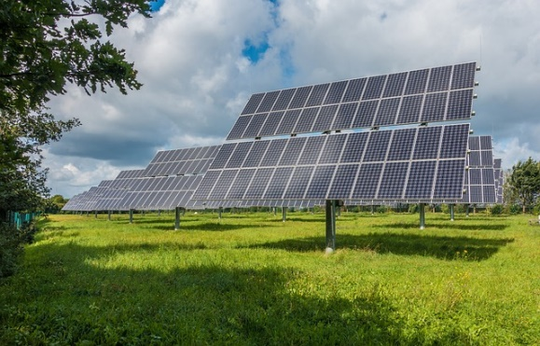

Biotechnology
Biotechnology offers a wealth of possibilities. Researchers study the medicinal properties, resilience, and composition of plants. Breeders develop new plant varieties that suit the changing climate. Researchers also search for the natural enemies of pests, so we will no longer have to use chemical pesticides. That way, trees and plants stay healthy for longer. Would you like to work on this in a lab?
Biotechnology can also be used to improve animal welfare. Could you develop better cattle feed so cows emit less CO₂ and methane? Technology can also target the human body. Would you like to design an app that keeps track of how healthy you are? Or a microchip that fits under the skin and tells you when your body needs carbohydrates?

Agriculture & horticultural systems
There are enormous technical possibilities in agriculture and horticulture. Technology can create more automation with smart machines, sensors, and engineering. It can make the green sector so much more sustainable. Would you like to build a robot that can pick strawberries? Or ensure the proper operation of a fully automated greenhouse? Would you let a self-steering tractor work the land accurately? Or share knowledge about new techniques for growing crops with the entire world?

Big data
Agriculture and horticulture are a paradise for big data. There is data about manure, feed, water, medication, waste, growth, nitrogen, ammonia, and more. All that information can be used for improvement and change, but how? Could you extract value from big data and apply it meaningfully on the farm? Or use data to improve crop cultivation? Do you want to get to work with smart farming?
Design
There is plenty of room for design in the green sector. Special food concepts are developed for festivals, amusement parks, and supermarkets. Fruits and vegetables can be offered as jewels at the farmers’ market. Designers are also at home in the flower industry. What do you think about food presentation? Could you make living works of art from plants and flowers?
Smart apps can help consumers understand the journey products take from their origins to the supermarket. With a 3D printer, horse saddles can be custom made and delivered individually. Could you create that design?
The fashion world is experimenting with the use of new materials, like plants and waste. Could you design a coat made from nettles, a dress made from manure, or a handbag made from coffee grounds? Or could you develop a smart bodywarmer to give newborn piglets a good start in life?

When other people think it can't get any better, you - as a researcher, lab technician, or engineer - keep going. Because you believe it can be done!



