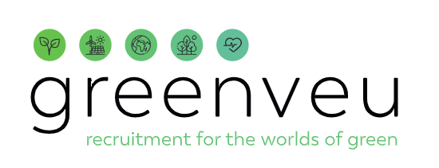


Food
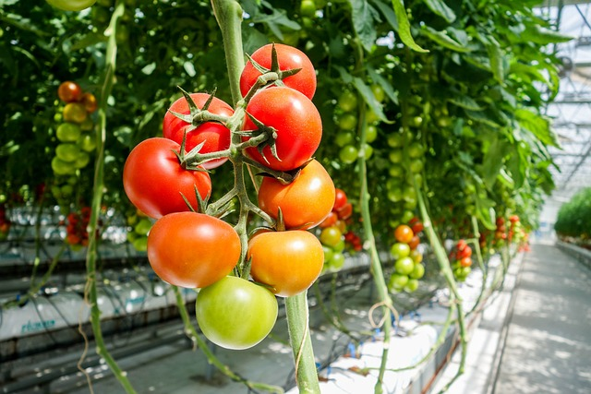
In 2050, there will be nine billion people on earth. To feed all those people, we will have to produce more food in the next 30 years than we have in the past 6,000 years. At the moment, humans are consuming one and a half times as much food as our planet can actually handle. That has to change. It will require sustainable food production and processing that does not damage ecosystems. You could be part of that, too.
In the world of Food, everyone contributes to a better world.

Food production & processing
The production and processing of food is invaluable across the globe. That’s why there is a lot of attention for improvement and innovation. Seeds can be bred to better fit the changing climate, and plant diseases can be reduced by growing crops in the right way. Would you like to work on plant breeding or crop mosaics? Or set up a pixel farm, a modern vegetable garden where vegetables are grown as needed?
Food production and processing also require quality controls and data analysis. Perhaps you’ll analyze the data from a cookie factory. Or make sure a bakery can adapt to the weather by making more baguettes when the weather is nice. You could research new sources of protein for a meatless hamburger, or design innovative packaging. Can you think of a form of food production that goes hand in hand with nature, like a food forest?
In the world of Food, you can work in a greenhouse or as a crop farmer. You could be a livestock breeder or a team leader in a dairy factory. And there are many other ways to farm. Could you become a seaweed farmer on the water, an insect farmer, or perhaps a city farmer with a vertical farm?

A job in the world of food offers many opportunities to contribute to a better and healthier world

Food & technology
The green sector is becoming more technical and digital. Many food processes use high-tech machines to ensure higher production, greater safety, and lower costs. Robots, drones, and data help farmers on smart farms work as efficiently and sustainably as possible.
Will you design, operate, or maintain high-tech machines? Or work on new technology for smart greenhouses or the production of cultured meat? Do you want to help farmers in dry Dubai grow vegetables in vertical farms with LED lights? Will you detect plant diseases even before the symptoms are visible? Or will you make it possible for people to print healthy food in their own kitchens?

The value of food
Food is available anytime, anywhere in our society. We can order our groceries with the push of a button and have them delivered the very next day. That’s why our appreciation of food and knowledge about the food chain is different than it used to be. Will you help society reevaluate our ideas about food? Do you want to give the producers of our food a human face again so they get the appreciation they deserve?

A job in the world of food offers many opportunities to contribute to a better and healthier world



